Biology Review Sheet
Chapter 16
Name ___________________________
Know Your vocabulary and root terms!!!

Short Answer:
1. What are the five different characteristics given in class are necessary for a plant to live on land?
a)

b)

c)

d)

e)

2. What were the two divisions of land plants given in your notes?
a)

b)

3. What were the two bryophytes mentioned in class?
a)
b)

4. What were the two types of seed plants mentioned in this chapter and what does
each name mean?
a)

b)

5. Angiosperms are divided into groups (a & b). Give the name of each of the two
groups and describe at least two characteristics of each.
a)
1)

2)

b)
1)

2)

6. Give the functions of the following.
a)Root:

b)Stem:

c)Leaf:

7. Give two characteristics of the plant kingdom.
a)
b)

8. Non-vascular plants do not have true roots stems and leaves even though the have
structures that look like they do. Why aren't these structures considered to be
true roots stems and leaves?

9. Why do ferns need to live in moist environments?

10. How is food and water transported in bryophytes?

11. Angiosperms are the most abundant plants. What makes them so successful?

12. Give the name of the two different types of stems, and explain the difference
between them.

13. What are xylem and phloem tissue and what is the difference between them?

14. What is vascular cambium?

Matching 1: In the space at the left write the letter of the item in column B that most closely matches the item in column A

Column A Column B
_____ 1. Pine a. vascular; wedge-shaped leaves; spores
_____ 2. Fern b. vascular; seeds; cones
_____ 3. Moss c. vascular; two cotyledons per seed
_____ 4. Corn d. non-vascular; small
_____ 5. Horsetail e. vascular; rhizome; spores
_____ 6. Bean f. vascular; one cotyledon per seed

Answers: bryophyte, ferns, angiosperm, gymnosperm , or any combination

Column A Column B
________________________ 1. Reproduce by seeds
________________________ 2. unprotected seeds
________________________ 3. vascular tissue
________________________ 4. no roots stems or leaves
________________________ 5. do not require water for fertilization
________________________ 6. have rhizomes
________________________ 7. have cones
________________________ 8. dicots and monocots
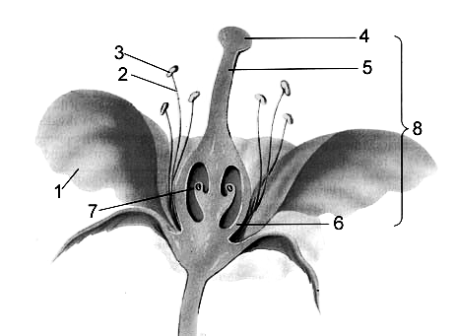
________________________ 9. have flowers

Know the Flower parts

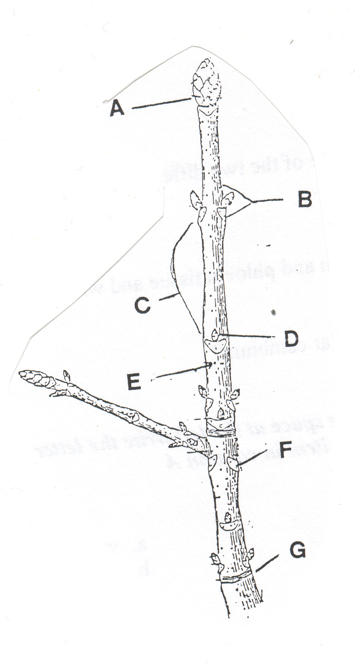
Label the woody stem.

Know the different types of leaves

compound pinnate, simple pinnate, compound palmate, simple palmate

Be able to identify the difference between monocots and dicots.

