Study Sheet
ch 17
Name _________________________
Know all of your “Root Terms” and vocabulary!!!!!

Short Answer & Fill in the Blank:
1. Give five characteristics of animals.
a)
b)
c)
d)
e)

2. Animals are classified into to main groups. What are they?
a)

b)

3. Name and explain the three different symmetries.

4. Identify and explain the four main areas of anatomy on a bilaterally symmetrical organism.

5. What are the three layers of developmental tissue?

a)_______________ b) ____________________ c)___________________

6. What phylum are sponges?

7. What is a hermaphrodite?

8. Give three characteristics of the phylum Cnidaria.
a.
b.
c.

9. Name and explain the two body forms of many cnidarians.

10. What organisms are included in the cnidaria group?

11. What organisms are included in the phylum Platyhelminthes?

Match each organism with its class or phylum writing the correct letter in the
space provided.
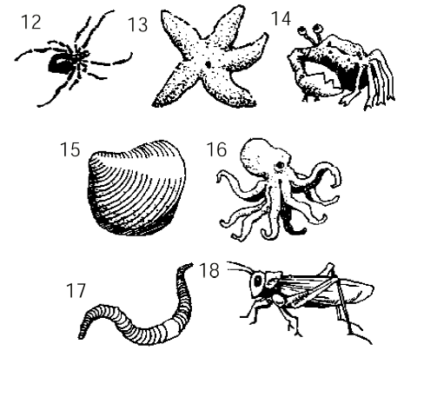

_____ 12. a. Insect
_____ 13. b. Echinoderm
_____ 14. c. Bivalve
_____ 15. d. Crustacean
_____ 16. e. Cephalopod
_____ 17. f. arachnid
_____ 18. g. Annelid

19. What characteristic do round worms (nematods) have that flat worms, cnidarians, and
porifera did not have?

20. Give two distinguishing characterisics of the annelids that make them different
than nematods, flat worms, cnidarians and porifera.
a.
b.

21. What are the three main classes of mollusks and give an example of each.
Class Example Organism
a.

b.

c.

22. What does the word arthropoda mean?

23. Give the five classes of arthropods given in your notes and give and
example of each.
Class Example Organism
a.

b.

c.

d.

e.

24. What are three examples of the phylum echinodermata.
a.

b

c

25. What is the difference between chordates and hemichordates?

26. Give three characteristics of chordates.
a.

b.

c.

27. What are the two main groups of vertebrates? Hint: based on where they get their body heat comes from.
a.

b.

28. What are the three classes of fish? Give and example of each.
Class Example
a.

b.

c.

29. Describe a typical amphibian.

30. What adaptations to reptiles have that allow them to live on land?

31. Give four characteristics of the class aves.
a.

b.

c.

d.

32. Give four charateristics of mammals that distinguish them from other animals.
a.

b.

c.

d.

33. Mammals are divided into three main groups according to development. What are
they?
a.

b.

c.

34. Draw a basic insect and name the three main body segments of the insect.

Use the following diagrams to answer questions 34-35
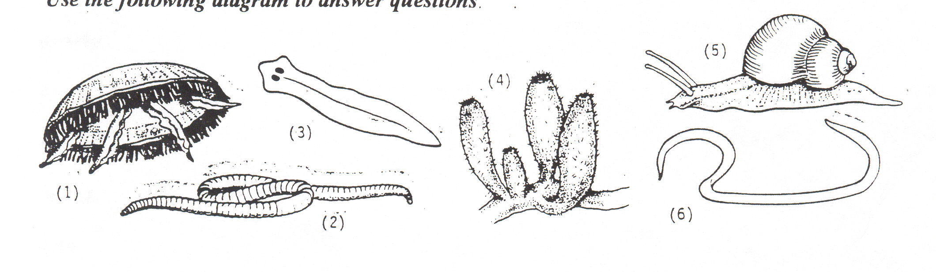

35. Which organism(s) has (have) two tissue layers?

36. Which organism(s) is a nematod?

37. Which organism is in the phylum platyhelminthes?

38. Which organism probably has tentacles with stinging cells?

39. Which organism has a muscular foot?

40. Which organism shows radial symmetry?

41. Which organism has a segmented body?

42. Which organism is a filter feeder?

