POPULATION BIOLOGY
Study Sheet

Name _______________________.

Know your vocab and root terms.

Words that you may use in the next section of the test:
0 Population growth density dependent density independent
Pecking order extinction immigration
Emigration endangered population density
Write the word or phrase that best completes the statement.
1. _____________________________ is a condition in which the birthrate equals the death rate and the a population graph having an S shape.

2. Social hierarchy is also known as a _____________________ __________________.

3. Food supply and living space are examples of _________________ _______________ limiting factors

4. The amount of oxygen and weather are examples of _________________________ __________________________ limiting factors.

5. _________________________ occurs when a species dies out due to competition with a different species for the same resources.

6. The swarming of bees from an overcrowded hive to a new location is an example of ______________________.

7. Name three limiting factors that effect population growth.

8. How do the sizes of predator and prey populations affect one another in achieving a balance?

9. Can the growth rate decrease and the actual population increase without immigration?

10. If the birth rate and the death rate are exactly the same, what does this say about the population?

11. In your own words, describe what you believe is the best answer to the potential human population problem?

Population growth can be shown with a J curve or and S shaped curve. Answer each question by identifying the curve described as J shaped or S shaped

- Which curve shows that a population has stopped increasing in size?

- Which curve shows that the size of a population will increase indefinitely?

- Which curve shows a population’s growth under ideal conditions?

- Which curve shows the growth of a rabbit population living in a forest?

- Which curve shows a population’s biotic potential?

Each of the graphs in Figure 27-1 shows a relationship between change in population size and time. Refer to the graphs as you answer the following questions.
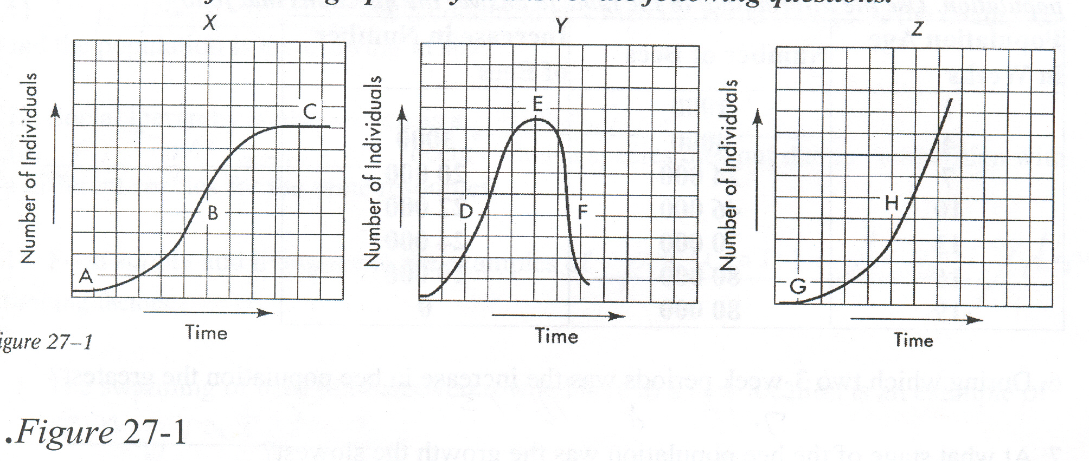
- Which graph represents growth under ideal conditions? How do you know?

- Describe what is happening in graph Y to the population size at point F.

- In graph X, what is happening to the population size at points A, B, and C?

- How does the birthrate of the organisms compare with the death rate at point C? At point F?

- The curve of which graph most closely resembles that expected for a frog population in a pond? For a lightning bug population?
- Suppose you were to place several mating pairs of rabbits on a small island having ample vegetation and no predators. Describe the changes you would expect to see in the rabbit population over time. Include a discussion of any limiting factors in your description.

- Once the island's carrying capacity for rabbits is reached, several mating pairs of foxes are introduced to the island. What effect will this have on the rabbit population of the island? Describe the changes in rabbit and fox populations you would expect to take place over time.

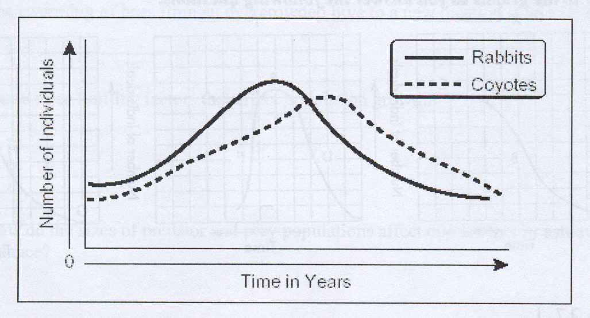
- This graph shows the average number of rabbits and coyotes in an area over time. What conclusion could be made from this data?

In your textbook, you read about density-dependent and density-independent limiting factors.
- Give an example of a density-dependent limiting factor.

- Give an example of a density-independent limiting factor.

- Explain the difference between an (r) strategist and a (K) strategist organism

