Biology Study Sheet
chapter 4

Name _____________________

Instructions: Answer the following questions as completely as possible in the space provided.
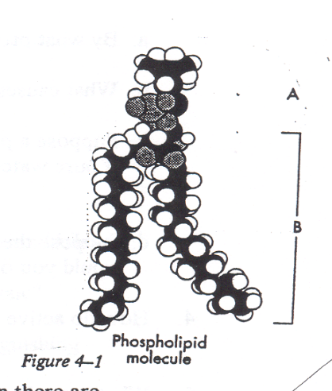
Know your vocabulary and root terms!!!!

Short Answer & Fill in the Blank:

1. Refer to figure 4-1 to answer the questions that follow.
a. What is shown by part A of the figure?

b. What is shown by part B of the figure?

c. Describe how each part of the molecule behaves in water when there are many of the molecules.

2. In the space below, sketch the arrangement of molecules, such as the one shown
on the previous page, in the plasma membrane.

3. By what process does water enter a one celled organism?

4. What causes water to enter any unicellular organism?

5. Suppose a paramecium were removed from a pond and placed in a container of pure water. What might you observe?

6. Suppose the paramecium were placed in a container of seawater. What
would you observe?

7. How do active transport and passive transport differ?

8. What is a selectively permeable membrane?

9. What is the role of carrier proteins in passive transport?

10. What are the three types of plasma membrane proteins involved in facilitated
diffusion?
a.

b.

c.

11. What are the three parts to the Cell Theory?
a.

b.

c.

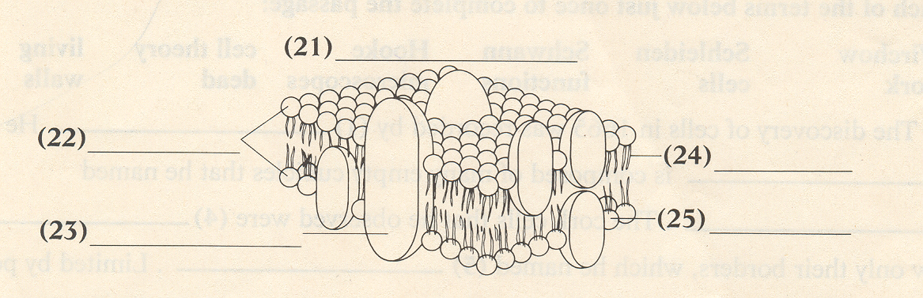
12. Write a title for the diagram and then label its parts.
(a)

(c)
(b)
(e)
(d)
13. What is a lipid bilayer?

14. What are the functions of cholesterol molecules embedded in the lipid bilayer?

15. Why is the current model of membrane structure called fluid mosaic?

16. What are three types of passive transport and what is their distinguishing
characteristic?

17. Complete the following table by checking the correct column for each example.
Example | Passive Transport | Active Transport
a. The random movement of ions

b. Net movement of particles from a region of lesser concentration to a region of greater concentration
c. The movement of oxygen and carbon dioxide across cell membranes
d. Energy is needed to move particles through the membrane

e. Cells in the gills of marine fish actively pump input from the cell
f. Water molecules move across a membrane without any energy input from the cell
18. What types of organisms have a cell wall?

19. What is a plant cell wall mostly composed of?

20. What are two functions of the cell wall?

21. Solid chunks of material are taken in by the plasma membrane through a process
called ___________________________ .

22. The name of the process by which liquid droplets are taken in by the plasma
membrane is ___________________________.

23. When does osmotic balance occur?

24. When the same numbers of particles are moving into the cell as moving out of the cell, what is this called?

23. Complete the table. To answer the first two questions, write yes or no in each
column. To answer the last question, write the correct word(s) in each column.
 | Endocytosis |  |  | Exocytosis
 | Phagocytosis | Pinocytosis | Receptor-aided | Exocytosis
a. Are substances taken into the cell
b. Are substances being expelled from the cell?
c. What types of substance(s) are taken into or expelled from the cell?

