The Sun – Earth – Moon System

Planet Earth
  - Shape
    - Spherical
    - Oval shaped
  - Rotation
    - West to east
    - Fifteen degree /hour
    - Rotation is just less than 24 hours
  - Magnetic field
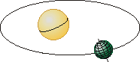
    - North and south magnetic poles
    - Protect the earth from solar wind
  - Earth’s revolution around the sun
    - Shape is elliptical
    - 365.25 days
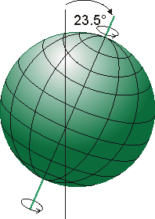
      - Closest to the sun on January 3
      - Farthest from the sun on July 4
  - Tilts on its axis 23.5 degrees
  - This tilt of the earth is what causes the seasons
    - Equinox
      - Autumnal Equinox 9/22 or 9/23
      - Spring Equinox 3/20 or 3/21
    - Summer Solstice
      - Summer 6/21 or 6/22
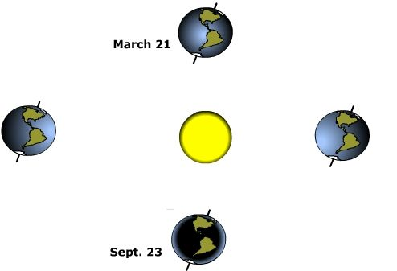
      - Winter 12/21 or 12/22

- The moon
  - Space object nearest to earth
  - Romans called it Luna which means shining
    - From the word Luna we get the word lunar, which refers to the moon
  - Features of the moon
    - Diameter – 3,476 km in diameter
    - Distance from earth - 384,400 km
    - Gravity 1/6 that of earth
  - Moon’s motion
    - Moon revolves around the earth in 27 1/3 earth days
    - Moon rotates on its axis
      - 1 moon day = 27 1/3 earth days
  - Phases of the moon
    - The moon is ½ illuminated most of the time (except during a lunar eclipse)
    - The moon phases we see depend on how much of the illuminated side we see, not on how much is illuminated
    - The moon revolves from west to east at 13 º / day
      - This causes the moon to come up 50 minutes later each 24 hour period
    - The movement of the earth and moon are the reason the moon appears to have phases
    - The names of the moon phases using the (DOC) Method
      - New moon – the moon is between the sun & earth
      - Waxing Crescent moon
      - First Quarter is ½ of the moon showing
      - Waxing Gibbous
      - Full
      - Waning gibbous
      - Last quarter
      - Waning crescent
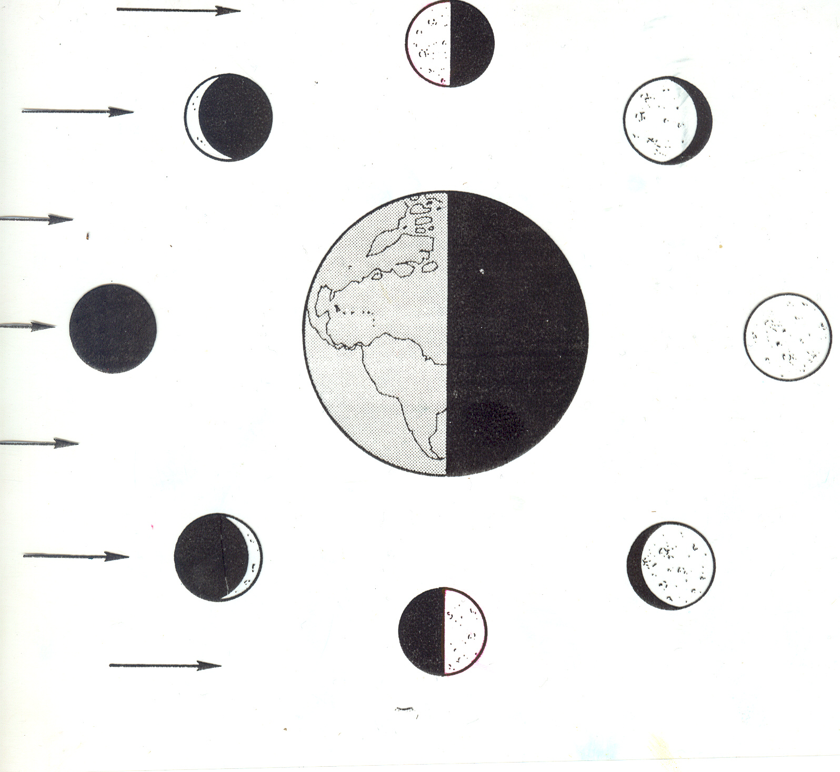

  - Eclipses
    - The result of shadows cast by the earth and the moon
    - There is a main shadow and a partial shadow
      - The main shadow is the umbra
      - The partial shadow is the penumbra
    - Lunar eclipse
      - When the mood moves into the earth’s shadow Umbra

Umbra
Penumbra

      - The moon is darkened
        - The moon looks like a copper red disc
        - The red tone of the moon is caused by the atmosphere of the earth bending the sun rays
  - Solar Eclipse – when the earth moves into the moons shadow
    - Solar eclipse is longest at the equator 7.5 minutes
    - When the sun shines through Deep valleys on the moon, during a solar eclipse, beads or string of bright light form and are called “Bailey’s Beads”
    - Partial eclipses are more common than total eclipses
    - How can an object the size of the moon cover an object the size of the sun?
      - The sun is 400 times larger than the moon
        - Sun diameter 1 392 000 km
        - Moon’s diameter 3 476 km
      - The sun is also 400 times farther away
        - Sun’s distance from earth 149,000,000 km
        - Moon’s distance from earth 384,400 km
  - Lunar surface and composition
    - Surface solid rock covered with dust
    - The moon has no atmosphere
      - Because of no atmosphere temperatures vary from 130º C to –170ºC in the shadows
    - Moon’s crust is 1 to 300 km thick
    - Pieces of rock from space bombard the surface since there is no atmosphere to burn up those things falling toward its surface.
    - Craters are the results of the meteorites hitting the surface of the moon
      - 30,000 named craters on the moon
      - Copernicus is 91 km from rim to rim
    - The moon plain is called Maria
      - Maria is Latin for sea
      - Maria is formed from hardened lava
    - Lunar mountains formed from huge chunks of rock hitting the moons surface
      - Mountains are as high as 5 km above the moons surface
  - Moons composition
    - Rocks brought from the moon by Apollo astronauts show composition much like earth
      - Moon’s crust oxygen, silicon aluminum, Iron, calcium
      - Moon dust is much like our sand
  - Origin of the moon
    - Appears to be the same age as earth
    - No signs of past life
    - One theory is moon another planet pulled in by earth’s gravity
    - Another theory is that the moon and earth formed from the same dust within gravitational pull.
    - Another theory is that during earth’s formation a piece was flung free from the earth
    - Impact theory- collision of mars sized object with earth

