Alternate Small LEGO Duck Plans plan # 1

Here are plans to build an alternate version of the small LEGO Duck sculpture.
Parts List white eye block
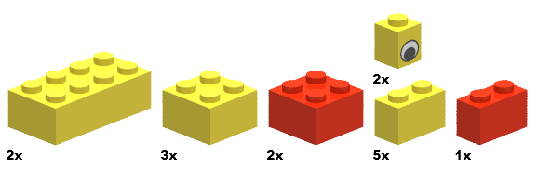
Yellow yellow red yellow red
Step-by-Step Building Instructions…

Start (yellow)
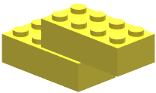

Step 1
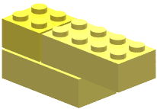

Step 2
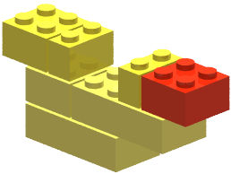
Red bill

Step 3
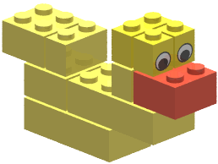

Step 4 (Flip Model)
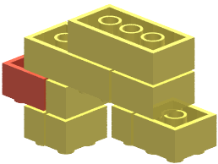

Step 5
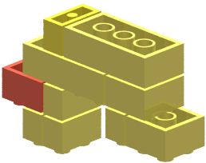

Step 6
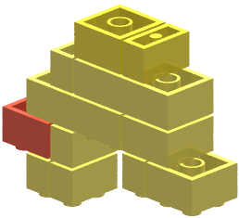

Step 7
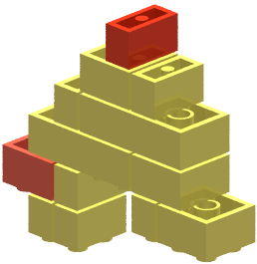
Red leg block

Step 8
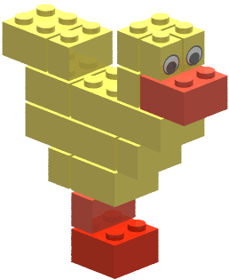
Red feet block

