**[LEGO Fish Plans](http://brickplayer.com/blog/2014/11/17/alternate-small-lego-fish-plans/" \o "Permanent Link to Alternate Small LEGO Fish Plans)** plan # 2

Here are plans to build an alternate version of the small LEGO Fish sculpture.

**Parts List**

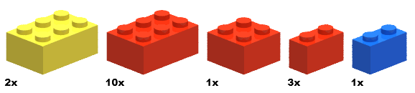

Yellow red /black red red blue

Step-by-Step Building Instructions…

**Start**



**Step 1**

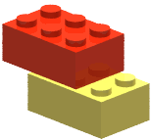

**Step 2**

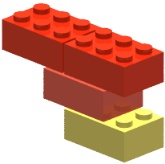

**Step 3**

blue eye block

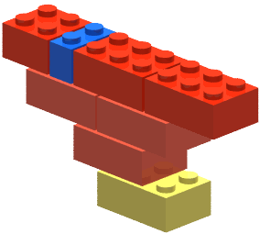

**Step 4 (Flip Model)**

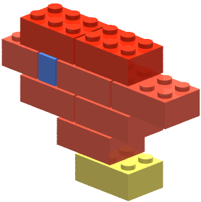

Yellow fin block block

**Step 5**

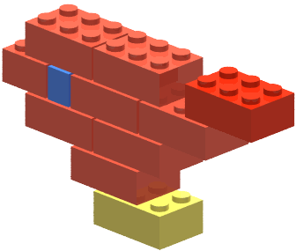

**Step 6**

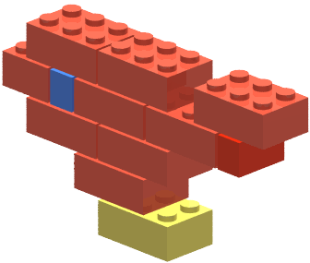

**Step 7**

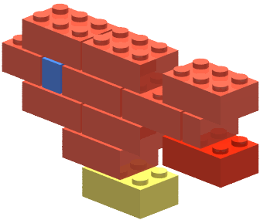

**Step 8**

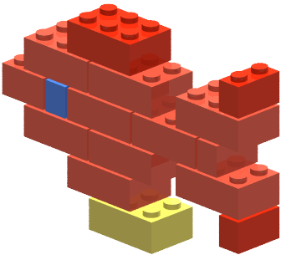

**Step 9**

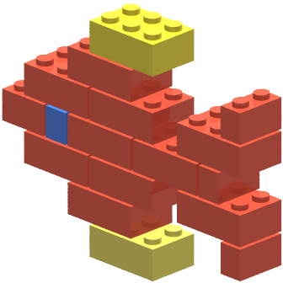

Yellow fin block block