**[LEGO Man Plans](http://brickplayer.com/blog/2014/11/17/alternate-small-lego-fish-plans/" \o "Permanent Link to Alternate Small LEGO Fish Plans)** plan # 3

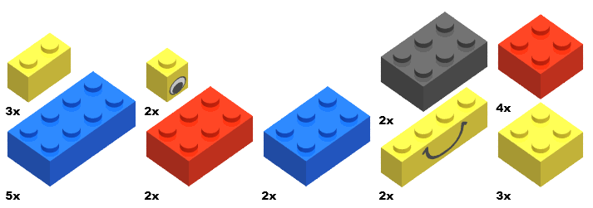

White White Black Red

**Blue Red Blue White White**

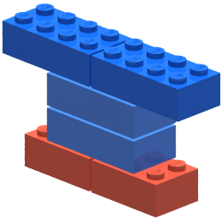**Start**

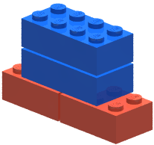

**Step 1 Blue Step 2 Blue**  
 **Red**

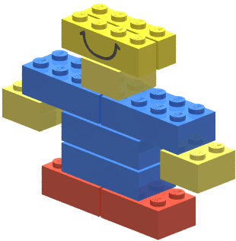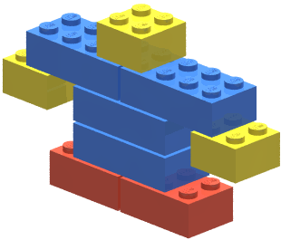

**Step 3 White Step 4 White**





**Step 5**  
 Blue cap

**Step 6**

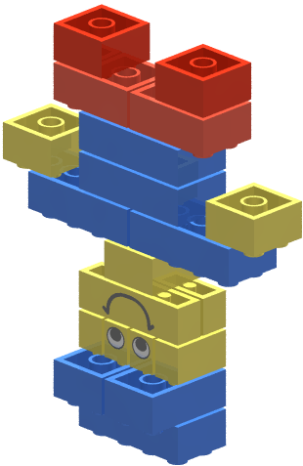

**Step 7**  
 **Step 8**

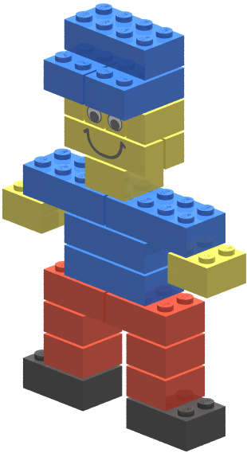

Step 9 Step 10   
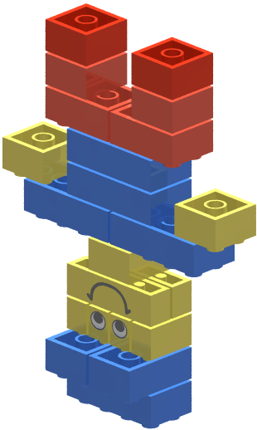 Black shoes