Life Science
Study Sheet

Name ________________________
Know your Vocabulary !!!!!
Short Answer:
  - Label the parts of a neuron using the following words: dendrite, axon, myelin sheath, cell body.

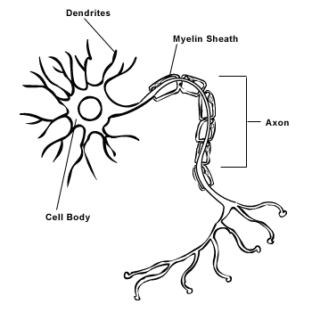
  - What direction does a nerve impulse travel in a neuron?

  - What is the electrical jump between nerves called?

  - What makes up the central nervous system?

  - What is the name of the neurons that receive information from the senses?

  - What is the name of the neurons that move muscles to respond to the stimuli?

  - What are the five senses?

  - Which organ receives the sense of touch?

  - Which organ receives light energy?

  - Which organ senses chemicals in the air?

  - Which organ senses chemicals in the mouth?

  - Which organ senses vibrations in the air?

  - What is the name given to all nerves outside of the central nervous system?

  - Draw and label the parts of the brain.

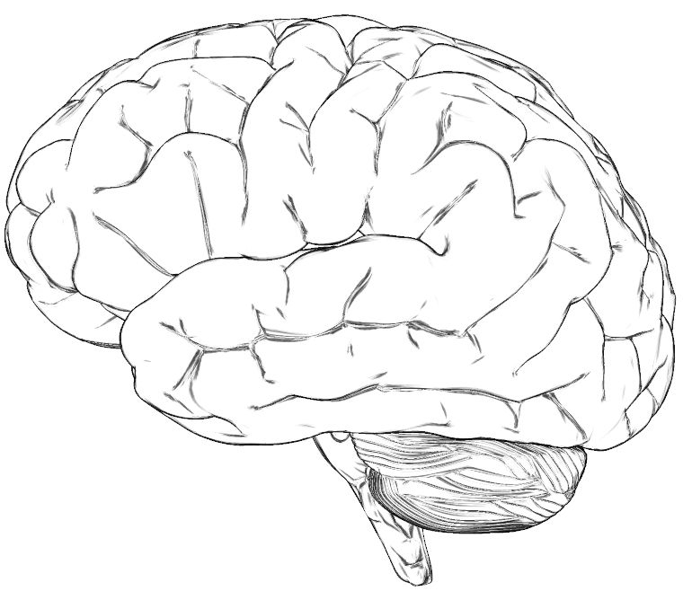
  - What is the difference between the somatic and the autonomic nervous system?

  - Label the parts of the eye using the following words: iris, cornea, optic nerve, retina, lense.

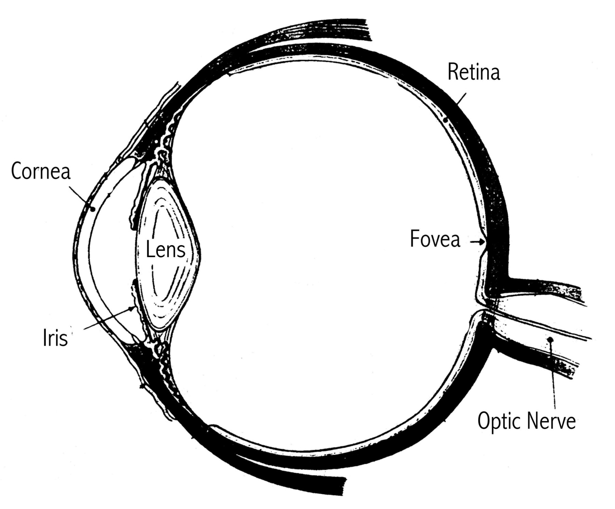

  - What part of the ear receives information to help you keep your balance?

  - Label the diagram of the ear using the following words: anvil, hammer, stirrup, ear drum, cochlea, semi circular canal.



