Name ________________________ STUDY GUIDE

Kingdom Monera
Write the letter of the term or phrase that best completes each sentence.
_____ 1. Organisms whose cells have no membrane-bound organelles are ______ .
a. prokaryotes b. eukaryotes

_____ 2. Thousands of ______ live on and in your body.
a. bacteria b. cyanobacteria

_____ 3. Organisms that use oxygen for respiration are ______ organisms.
a. aerobic b. anaerobic

_____ 4. A ______ is a substance that absorbs light.
a. bloom b. pigment

_____ 5. Some bacteria have a thick ______ that surrounds the cell wall.
a. membrane b. capsule

_____ 6. Most bacteria reproduce by ______
a. tubes b. fission

_____ 7. Monerans that live in the intestines of cattle are ______ bacteria.
a. anaerobic b. aerobic

_____ 8. Some bacteria have a whiplike tail called a ______ .
a. bloom b. flagellum

Under each picture, write the name of each kind of bacteria.
C
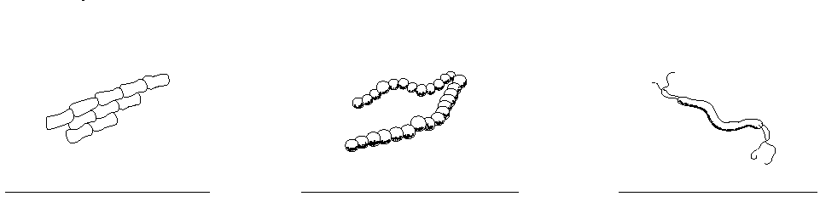

Monerans in Your Life
Tell whether each of the following are harmful or helpful.
16. bacteria used to make foods:_____________________________________

17. pathogens: ___________________________________________________

18. saprophytes: __________________________________________________

19. antibiotics: ____________________________________________________

20. toxins: _______________________________________________________

21. botulism bacteria: ______________________________________________

22. nitrogen-fixing bacteria: _________________________________________

Directions: Write the correct term from the word bank on the line next to its definition.

aerobe
bacteria
eubacteria
producer
anaerobe
conjugation
fission
van Leeuwenhoek
archaebacteria
consumer
flagella

___________________1. an organism that uses oxygen to break down food to obtain energy
___________________2. an organism that makes its own food using energy from the Sun
_________________3. whiplike tails that help bacteria move around in moist areas

___________________4. one celled prokaryotic organisms that occur alone, in chains, or groups
___________________5. kingdom of bacteria that lives in extreme environments-salty, acidic, or very hot
___________________6. an organism that lives without oxygen

___________________7. a type of asexual reproduction in which two new bacteria cells, identical to each other and the original cell, are produced
___________________8. Dutch merchant who used a microscope to discover bacteria

___________________9. an organism that breaks down and consumes other organisms for energy

__________________10. a type of sexual reproduction in which bacteria exchange genetic material

__________________11. the largest bacteria kingdom; classified into small groups by their shape, structure, how they obtain food, type of food, and the wastes they produce
Directions: Give the function of each of the following features found in a bacteria cell. (Hint: Refer to Figure 2 and your text for additional information.)
12. Cytoplasm:
13. Flagellum:
14. Capsule:
15. Cell membrane:
16. Cell wall:
17. Ribosomes:
18. Plasmid:

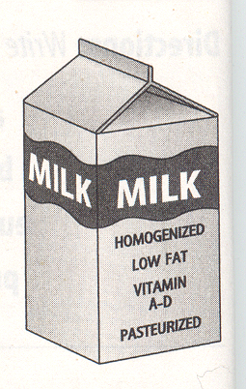
Directions: Answer the following questions on the lines provided.
- What word on the milk carton tells you that the dairy eliminated pathogens when producing the milk?

- What process kills harmful bacteria without much effect on the taste of the food? Describe the process.

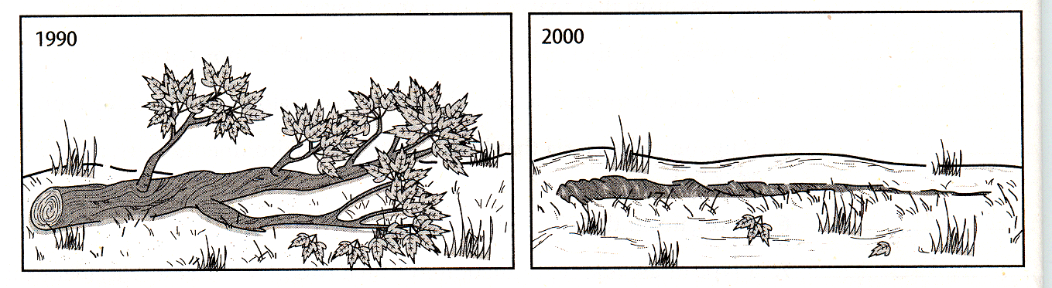
- In the illustration above, a change has taken place over time. What kind of bacteria caused the change?

- How does this change help other organisms in the environment?

- What kind of bacteria annually save farmers millions of dollars in fertilizer costs

- What two kinds of plants have these bacteria in their roots?

- What can prevent some bacterial diseases?

- What kind of drugs can kill bacteria?

- What are poisons produced by pathogens called?

- What are the thick-walled cells of botulism bacteria called?

