Study Sheet
ch 22
Name __________________

Short Answer & Fill in the Blank

1. What causes the phases of the moon?

2. Where are the suns rays most direct on the earth on summer solstice?

3. A rock weighing 120 Newtons on earth would weigh _________ Newtons on the
moon since the moons gravity is 1/6 that of earth.

4. The lunar plains are called _____________.

5. When the moon passes through the earth's umbra a (an) _____________ lunar
eclipse occurs.

6. What are Bailey's beads?

7. What moon phase can a solar eclipse occur during?

8. How were the moon's craters formed?

9. What area of the earth would you be able to see a solar eclipse for the longest
time?

10. When the moon moves so that its umbra shadows an area on the earth a
_______________ eclipse occurs.

11. How much later does the moon come up each night?

12. The slow movement of the moon around on its axis is called ______________.

13. How many degrees does the earth rotate in one hour?

14. The different shapes of the moon we can see are called ________________.

15. What is the most abundant element on the moon?

16. Why do we see only one side of the moon?

17. Which way does the moon revolve?

18. Why does the moon appear to rise in the east?

19. What is the difference between rotation and revolution?

20. What is the shape of the earth?

21. How many degrees does the earth tilt of it axis?

22. What is the shape of the earth's path as it revolves around the sun?

23. Explain one theory of the moon's origin?

24. In your opinion, do you think that man should pursue returning to the moon or not.
Why?

25. Why is it 130 C on the lighted side of the moon and in the shadow of a rock it would be -170C.

26. Explain equinox

27. What month of the year is the earth closest to the sun and what month of the year
is the earth furthest from the sun?

- How does the earth's magnetic field protect life on earth?

- Why does the moon and sun appear to be the same size?

- What month of the year does the sun shine most directly on the Tropic of Cancer.

- What month of the year does the sun shine most directly on the Tropic of Capricorn.
33. What time of the year is equinox?

- What causes the aurora borealis?

- Write the dates in the box next each earth and write whether it is solstice or equinox.

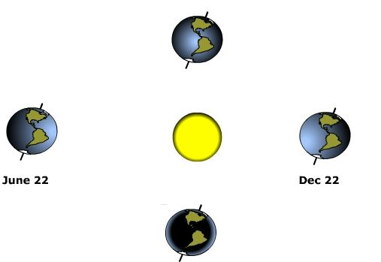

- Label the boxes below.

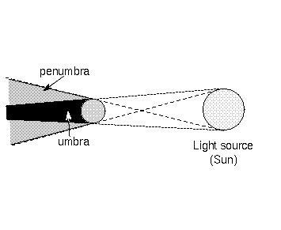

Instructions: Study the diagram below and answer each of the questions as directed.
C
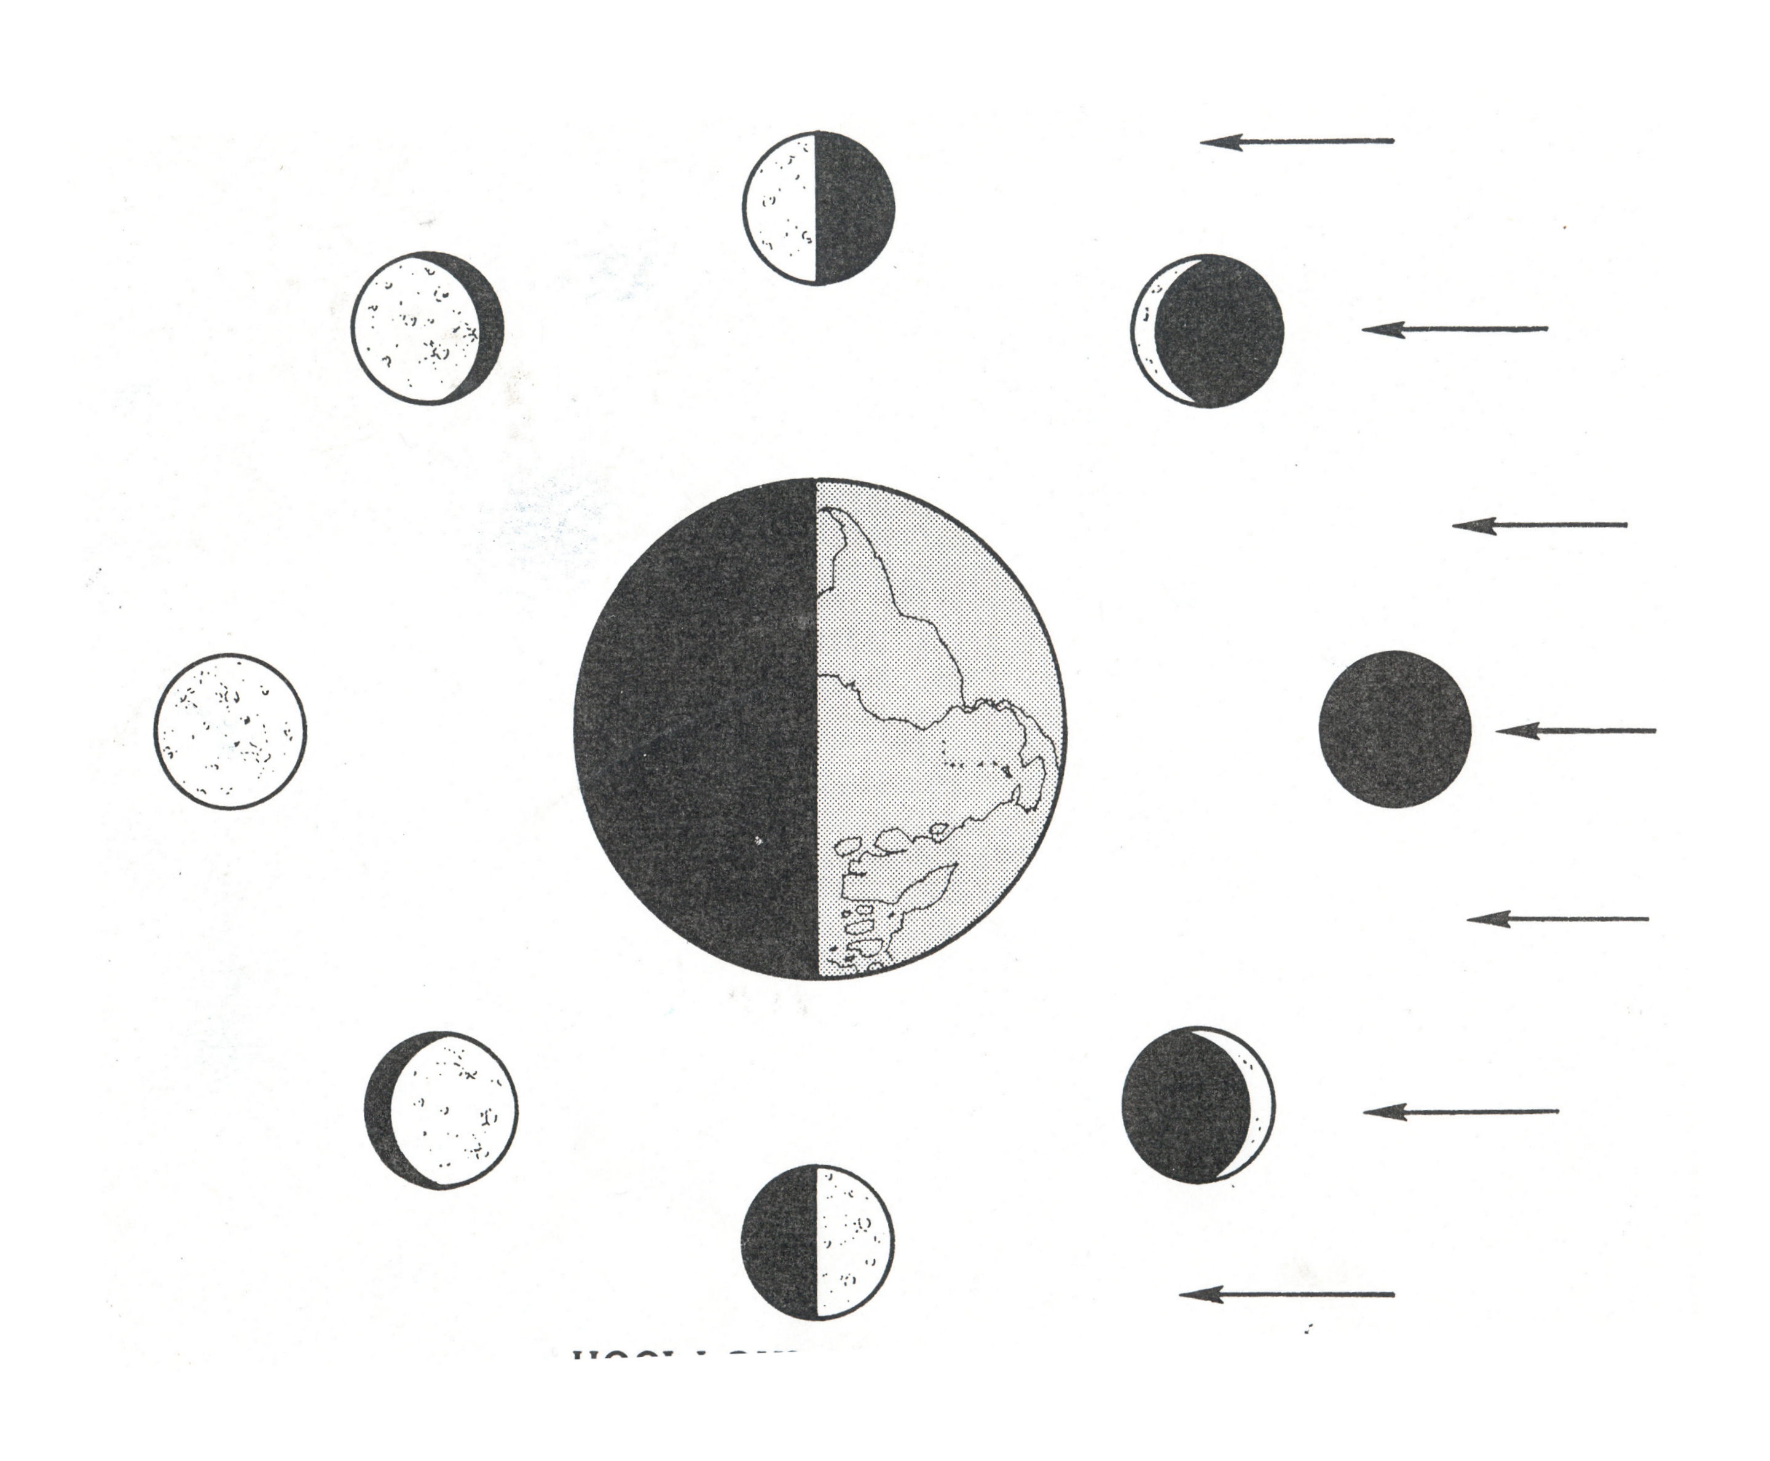
B
A
D

E
F
G

- Identify the moon phase of position D. _________________________________

- Identify the mood phase of position A. _________________________________

- Identify the moon phase of position B. _________________________________

- Identify the moon phase of position C. _________________________________

- Identify the moon phase of position F. _________________________________

- Identify the moon phase of position G. ________________________________

- What does the letter E represent? ________________________________

- Which letter represents the moon’s position in a solar eclipse? ______________

- How many days are required for the moon to go from A – A? ______________

- Which letter represents the moon’s position in a lunar eclipse? _____________

